W-00
YEAR 9 SCIENCE
ENERGY AND CHANGE
REVISION

1. Explain the differences between solids, liquids and gases in terms of the Kinetic Theory and the following points.

(a) How the particles are arranged in each phase.
(b) How the particles move in each phase.

2. Define the following terms.

(a) temperature (b) heat (c) thermal energy

3. Explained how heat is transferred in the following.

(a) A piece of copper wire that is heated at one end.
(b) A pot of warm water that is being heated.
(c) A room with a small gas heater at floor level.

4. Metals have a very high thermal conductivity while gases are very low. Explain this difference.

5. Some very expensive cookware has copper bottoms on all the pots and pans. Suggest a reason for this.

6. Sports people who injure themselves are advised to put ice or a cold pack immediately on the injury to limit any internal bleeding. Why does the ice feel cold on the skin?

7. Radiators on cars, trucks and other engines are painted black and have lots of very fine "fins" which allow the air to pass through. How do these two features make the radiator an efficient cooling device for the water carrying heat away from the engine?

8. Draw a simple labelled diagram to explain how a sea breeze occurs during the summer.

9. Parents become quite annoyed when one of their children stands in front of the refrigerator with the door open, thinking about what they would like to take from it. The cold air "falls" out of the fridge onto their feet and the motor starts top chill the inside again once the door closes. This costs money in the long run!

Why does the cold air "fall" out?

10. Explain how a vacuum flask keeps coffee hot. (Refer to how it uses conduction, convection and radiation in its design.)

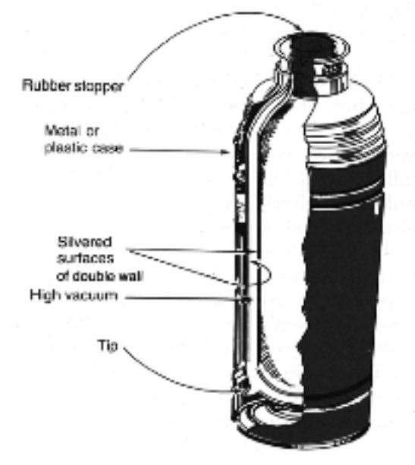
11. Use the diagram below to explain how a commercial solar hot water system works. Reference should be made to the processes of conduction, convection and radiation.

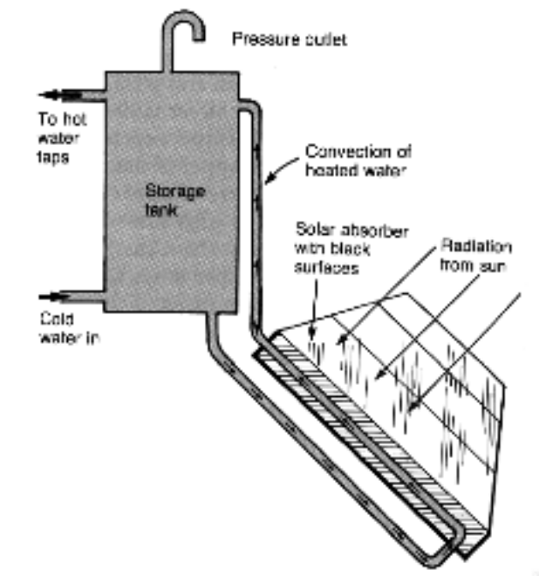

12. Himalayan rabbits have black feet, ears and noses. Why is this a good adaptation for this animal?

13. What sort of radiation do all objects radiate if they are at a temperature higher than their surroundings?

14. A builder is trying to work out whether an insulation of white polystyrene that is 2.50 cm thick is better in the roof of a house than fibreglass batts which are 4.00 cm thick.

Use the table on page 134 of Science Directions 3 to work out which is best. A calculation is necessary.

15. A dark coloured and woolly jumper is a must for some people in our winter season. Give two reasons why such a jumper keeps a person warm.

16. The Greenhouse Effect is a major environmental concern for our planet.

(a) Use a labelled diagram to explain in simple terms what this effect is.
(b) Which gas is the major contributor to the effect?
(c) Give two ways in which humankind contributes to the production of this gas.
(d) Explain one major consequence of this effect on the Earth.

